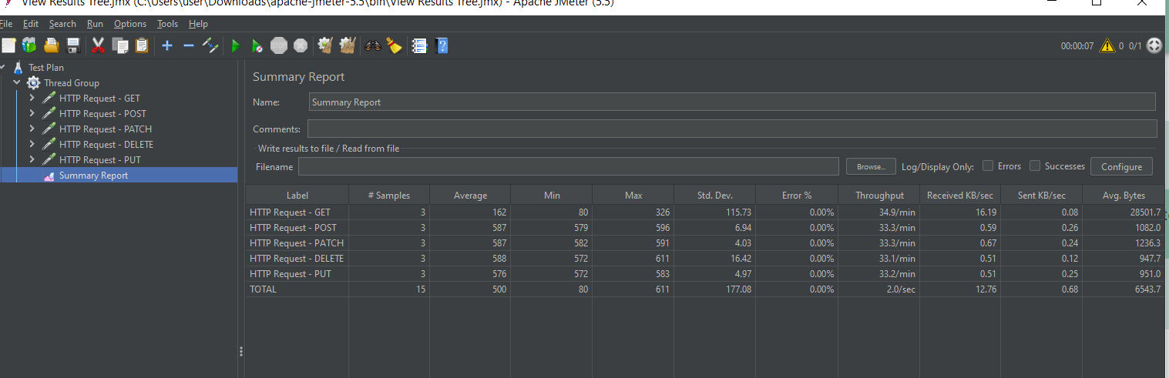

The average time for the get request was 162 ms, this is approximately 5 times less time than any of the requests to modify or delete data.

The highest amount of bytes received was from the get response because it receives all the data from the endpoint where as the other queries only modify or delete data.